1449/2
Matematik
Kertas 2

JAWATANKUASA PANITIA MATEMATIK DAERAH MUAR

SPM PERCUBAAN 2019

SIJIL PELAJARAN MALAYSIA

MATEMATIK 1449/2

Kertas 2

PERATURAN PEMARKAHAN

Markah = $\frac{\text{Kertas}1+\text{Kertas}2}{\text{140}}×\text{100}\text{\%}$

Peraturan Pemarkahan ini mengandungi 12 halaman bercetak

SKEMA PEMARKAHAN
PEPERIKSAAN PERCUBAAN SPM 2019

MATEMATIK KERTAS 1 ( 1449/1)

1 | C | 21 | B
2 | B | 22 | B
3 | C | 23 | B
4 | B | 24 | A
5 | C | 25 | C
6 | D | 26 | C
7 | B | 27 | A
8 | C | 28 | B
9 | B | 29 | A
10 | A | 30 | C
11 | C | 31 | B
12 | C | 32 | D
13 | D | 33 | A
14 | D | 34 | D
15 | D | 35 | D
16 | A | 36 | C
17 | C | 37 | A
18 | B | 38 | A
19 | B | 39 | B
20 | C | 40 | D

MATEMATIK KERTAS 2 ( 1449/2)

Bahagian A

No. Soalan | Peraturan Pemarkahan |  | Markah
1 | 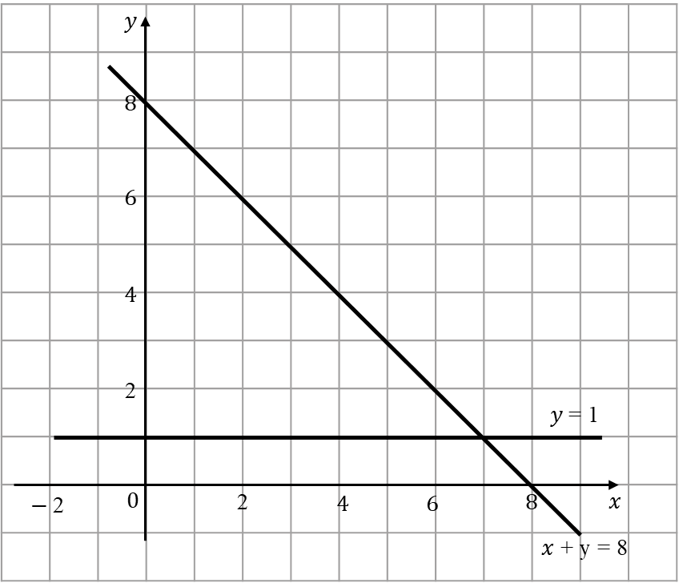  Garis lurus y = 2x dilukis dengan betul (penuh atau bintik )  Rantau betul dilorek  Nota:  - Rantau yang memuaskan mana-mana dua ketaksamaan berikan P1  - Tolak 1 markah dari K1P2 jika y = 2x garis penuh. |  | K1  P2  3
2 | 3h${}^{2}$− 5h −12 = 0  $\left(3h+4\right)\left(h−3\right)$= 0 atau setara  $h=\frac{−4}{3}; h=3$  Nota: 1) Terima “ = 0 “ untuk K1K1  2) Abaikan susunan untuk K1 pertama |  | K1  K1  N1N1 | 4
3 | 6p – 2q = 18 atau 2p − 4q = 16 atau setara  5p = 10 atau $−\frac{\text{10}}{3}\text{q }=−1\text{ 0}$ atau setara  ATAU  p = 3 + $\frac{1}{3}q$ atau p = 8 + 2q atau  q = 3p − 9 atau q = $\frac{1}{2}\text{p - 4}$ (K1)  5p = 10 atau $−\frac{\text{10}}{3}$q = −10 atau setara (K1) |  | K1  K1 | 4
4 | a) $∠\text{LSK} \text{atau} ∠\text{KSL}$  b$\begin{aligned}\text{tan}θ=\frac{4}{\text{10}} \\ θ={\text{57}}^{o}\text{48}' \text{atau}\begin{matrix} \text{21}\text{.}8^{o}\end{matrix}\end{aligned}$) |  | P1  K1  N1 | 3
5 | $$\frac{1}{3}×\frac{\text{22}}{7}×5^{2}×9$$  $$\frac{1}{2}×\frac{4}{3}×\frac{\text{22}}{7}×2^{3}$$  $$n=\frac{\frac{1}{3}×\frac{\text{22}}{7}×5^{2}×9}{\frac{1}{2}×\frac{4}{3}×\frac{\text{22}}{7}×2^{3}}$$  $$\begin{aligned}=\frac{\text{235}\text{.}\text{71}}{\text{16}\text{.}\text{76}} \\ =\text{14}\text{.}\text{06}\end{aligned}$$  = 14 |  | K1  K1  K1  K1  N1 | 5
6 | - Kecerunan SR = atau setara  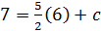 atau 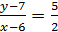 atau setara  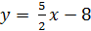 atau setara  - 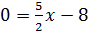  atau setara |  | P1  K1  N1  P1  N1 | 5
7 | - Statement / Pernyataan  - Implikasi 1 : Jika , maka  Implikasi 2 : Jika , maka  - 5n + 1, di mana n = 1, 2, 3 |  | P1  P1  P1  K1N1 | 5
8 | - $$a+b=8$$  $$\text{29}a+\text{32}b=\text{241}$$  $$\left(\begin{matrix}1 & 1 \\ \text{29} & \text{32}\end{matrix}\right)\left(\begin{matrix}a \\ b\end{matrix}\right)=\left(\begin{matrix}8 \\ \text{241}\end{matrix}\right)$$  $$\left(\begin{matrix}a \\ b\end{matrix}\right)=\frac{1}{\text{32}−\text{29}}\left(\begin{matrix}\text{32} & −1 \\ −\text{29} & 1\end{matrix}\right)\left(\begin{matrix}8 \\ \text{241}\end{matrix}\right)$$  $$\begin{aligned}a=5 \\ b=3\end{aligned}$$ |  | P1  P1  P1  K1  N1  N1 | 6
9 | - $\frac{{\text{45}}^{0}}{{\text{360}}^{0}}×2×π×7$ atau  $$\frac{{\text{135}}^{0}}{{\text{360}}^{0}}×2×π×\text{21}$$  $\frac{{\text{45}}^{0}}{{\text{360}}^{0}}×2×π×7$ + $\frac{{\text{135}}^{0}}{{\text{360}}^{0}}×2×π×\text{21}+7+\text{14}+\text{21}$  = 96.98  - $\frac{{\text{45}}^{0}}{{\text{360}}^{0}}×π×7×7$ atau  $\frac{{\text{135}}^{0}}{{\text{360}}^{0}}×π×\text{21}×\text{21}$ atau  $$\frac{{\text{90}}^{0}}{{\text{360}}^{0}}×π×\text{14}×\text{14}$$  $\frac{{\text{45}}^{o}}{{\text{360}}^{0}}×π×7×7+$$\frac{{\text{135}}^{0}}{{\text{360}}^{0}}×π×\text{21}×\text{21}−$$\frac{{\text{90}}^{0}}{{\text{360}}^{0}}×π×\text{14}×\text{14}$  = 384.85 |  | K1  K1  N1  K1  K1  N1 | 6
10 | a) S = { (1,O), (1,C), (1,A), (1,P), (2,O), (2,C), (2,A), (2,P), (5,O), (5,C), (5,A), (5,P), (10,O), (10,C), (10,A), (10,P)}  b) i. A = { (1,A), (5,A)}  $P(A)=\frac{2}{\text{16}}$  ii. B = { (1,O), (2,O), (5,O), (5,C), (5,A), (5,P), (10,O)}  $P(B)=\frac{7}{\text{16}}$ |  | P2  K1  N1  K1  N1 | 6
11 | - Uniform speed /laju seragam = 18 ${\text{ms}}^{−1}$  $\begin{aligned}\frac{\text{14}−\text{20}}{\text{20}−0} \\ =−\frac{6}{\text{20}}@−\frac{3}{\text{10}}{\text{ms}}^{−2}\end{aligned}$  b)  $\begin{aligned}\left(\frac{1}{2}×(\text{20}+\text{14})×\text{20}\right)=\text{220}+\left[8×(t−\text{30})\right] \\ \end{aligned}$$8t=\text{360}$$\begin{aligned}t=\text{45} \\ \end{aligned}$c) Jarak dilalui = |  | P1  K1  N1  K2  N1 | 6
12 | - x = −4, y = 26  x = 2, y = - 4  Note:  - If not stated, give K1K1 for the table  @ if points are correctly marked on the graph  @ the curve passes exactly through the points.  - Graph :  Axes are drawn in the correct direction with uniform scale. in the range − 4 < x < 4 and -11 y 26.  All 7 points and 2 points* are correctly marked  Smooth curve and continuously in range of − 4 < x < 4 with no straight line parts and passing through all the correct 9 points.  Note:  (i) 7 @ 8 points are correctly plotted, K1  (ii) Other scale used, minus 1 mark from the KN marks obtained.  - i)  ii)  - The equation y = 3x + 9  Straight line y = 3x + 9 correctly drawn and meet the curve.  The value of x :  Note:  (i) Allow N mark if x is shown on the graph.  (ii) The value of x obtained by calculation, give N0 | K1  K1  K1  K2  N1  K1  K1  K1  K1  K1  N1 |  | 12
13 | - (i) (5, 8)  * (5,6) ditulis atau diplot, beri P1  (ii) (0, -1)  * (-1,2) ditulis atau diplot, beri P1  - (i) (a)R = Pantulan pada garis x = 1  (b)P = Pembesaran, dengan faktor skala ½ pada  pusat W (-6,2)  (ii) 23.5 = (1/2)² (lorek + 23.5)  23.5 (4) = 23.5 + lorek  Lorek = 70.5 | P2  P2  P1P1  P1P1P1  K1  K1  N1 |  | 12
14 | (a)  Titik Tengah  Sempadan Atas  Kekerapan Longgokan  (b) Mean / Min  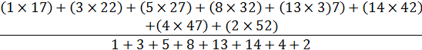  36.7 atau  Nota:  Tanpa kerja beri K2  (c) Ogif  Paksi dilukis pada arah yang betul dengan skala seragam  8 titikdiplotdengan betul  Nota:  *6 atau *7 titikdiplot dengan betul atau lengkung melalui titi dengan menggunakan sekurang-kurangnya 6 sempadan atas yang betul, beri K1  Lengkung yang licin dan berterusan tanpa sebarang garis lurus yang melalui untuk semua 8 titik yang betul | K1  K1  K2  K2  N1  P1  K2  N1  K1
  Mass (kg)  Jisim (kg) | Midpoint  Titik Tengah | Upper Boundary  Sempadan Atas | Cumulative Frequency  Kekerapan Longgokan
  10 – 14 | 12 | 14.5 | 0
  15 – 19 | 17 | 19.5 | 1
  20 – 24 | 22 | 24.5 | 4
  25 – 29 | 27 | 29.5 | 9
  30 – 34 | 32 | 34.5 | 17
  35 – 39 | 37 | 39.5 | 30
  40 – 44 | 42 | 44.5 | 44
  45 – 49 | 47 | 49.5 | 48
  50 – 54 | 52 | 54.5 | 50
15 | 3 cm  4 cm  6 cm  A  B  F  G  Bentuk yang tepat  Semua garis penuh  AF < AB < BG  Ukuran tepat kepada ±0.2cm dan semua sudut di semua bucu = 90⁰ ± 1⁰  3 cm  3 cm  8 cm  J  K  L  H  G  M  b) (i)  Bentuk yang tepat  Semua garis penuh  KL = LH < JK  Ukuran tepat kepada ±0.2cm dan semua sudut di semua bucu = 90⁰ ± 1⁰  (ii)  8 cm  1 cm  3 cm  F  J  G  H  K  E  Bentuk yang tepat  Semua garis penuh (Abaikan garis JK)  J – K bersambung dengan garis putus-putus JK terletak antara GF dan EH  FJ < JG < GH  Ukuran tepat kepada ±0.2cm dan semua sudut di semua bucu = 90⁰ ± 1⁰ | K1  K1  N1  K1  K1  N2  K1  K1  K1  N2
16 | - (40⁰U/N, 155⁰B/W)  - $$\frac{\text{5100}}{\text{60}}$$  $\frac{\text{5100}}{\text{60}}−\text{40}$  ${\text{45}}^{0}S$  - 25º + 37º = 62º  62 x 60 x kos 40º  2849.69 b.n.  - (i) 2849.69 + (40º x 60)  = 5249.69 b.n  .  (ii) $\frac{\text{5249}\text{.}\text{69 }}{\text{500}}$  = 10.5 jam / hours | P1P1  K1  K1  N1  K1  K1  N1  K1  N1  K1  N1

O
-1
2
3
1
-2
-3
x
4
y
25
15
30
5
20
10
-5
-10
-4

14.5
19.5
24.5
29.5
39.5
44.5
49.5
34.5
54.5
Sempadan Atas
5
20
15
10
40
35
30
25
45
50
Kekerapan Longgokan
X
X
X
X
X
X
X
X
X

